Walkthrough 5 Controllers

<https://sapui5.hana.ondemand.com/#/topic/50579ddf2c934ce789e056cfffe9efa9>

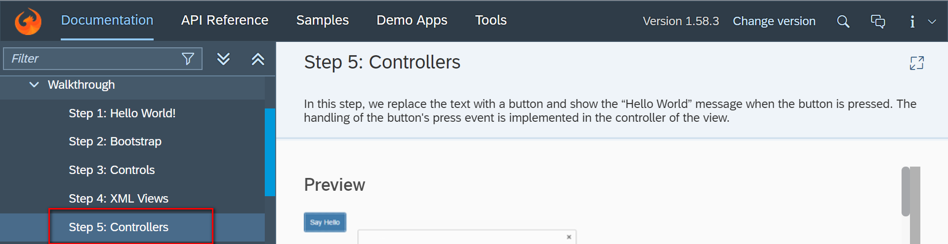

Git:

Result:

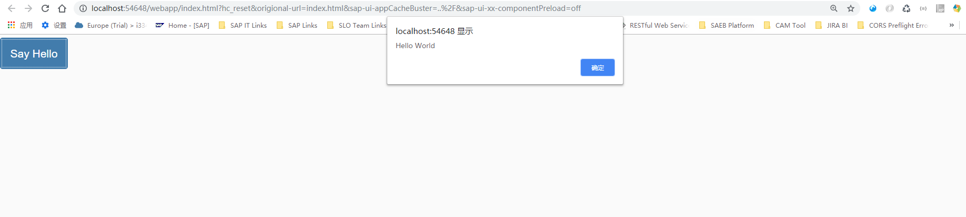

2018/11/02 XiaoMi Beijing Zac,Xie